1. Write a program which will find the factorial of a given number. Exit the program if the input number is negative. **Test case:** Input number = 5, Factorial is=5*4*3*2*1.

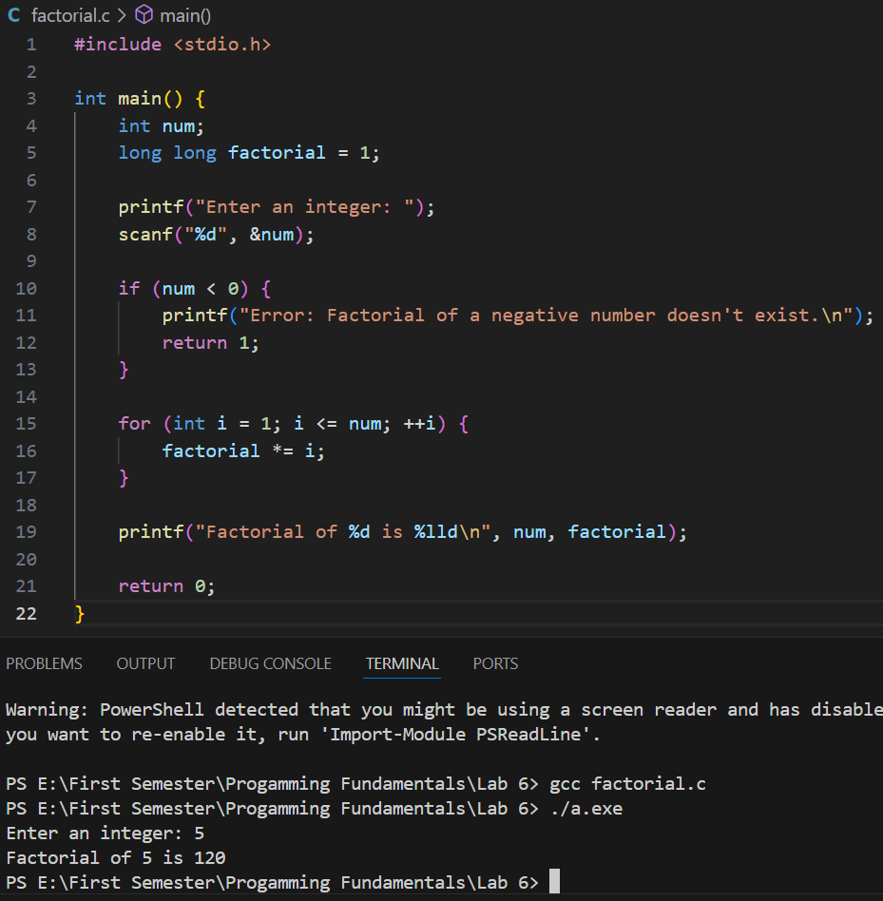

1. Write a program which will generate the Fibonacci series up to 1000. Also find the sum of the generated Fibonacci numbers divisible by 3, 5 and 7 only.

**Fibonacci series is:**1 1 2 3 5 8 13 25..........

**Note:** Do this task by using ***for loop*** and ***while loop***. Also identify which one is more efficient?

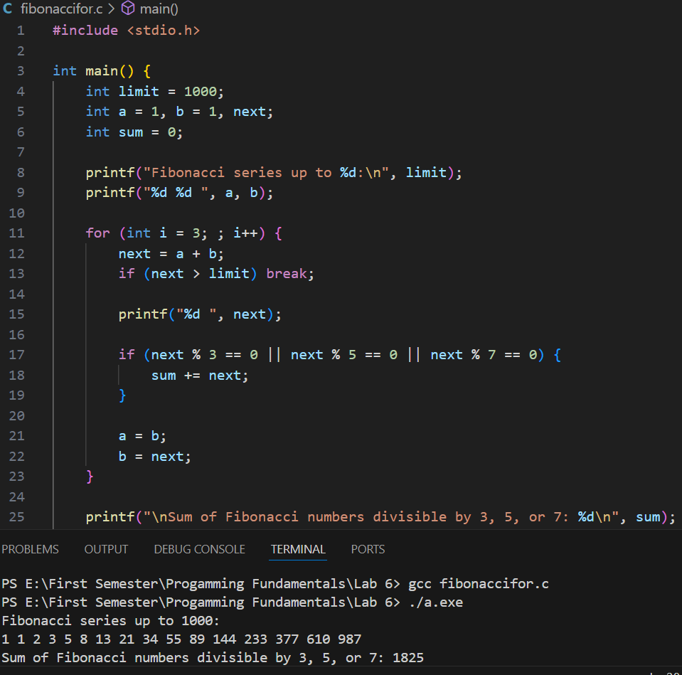

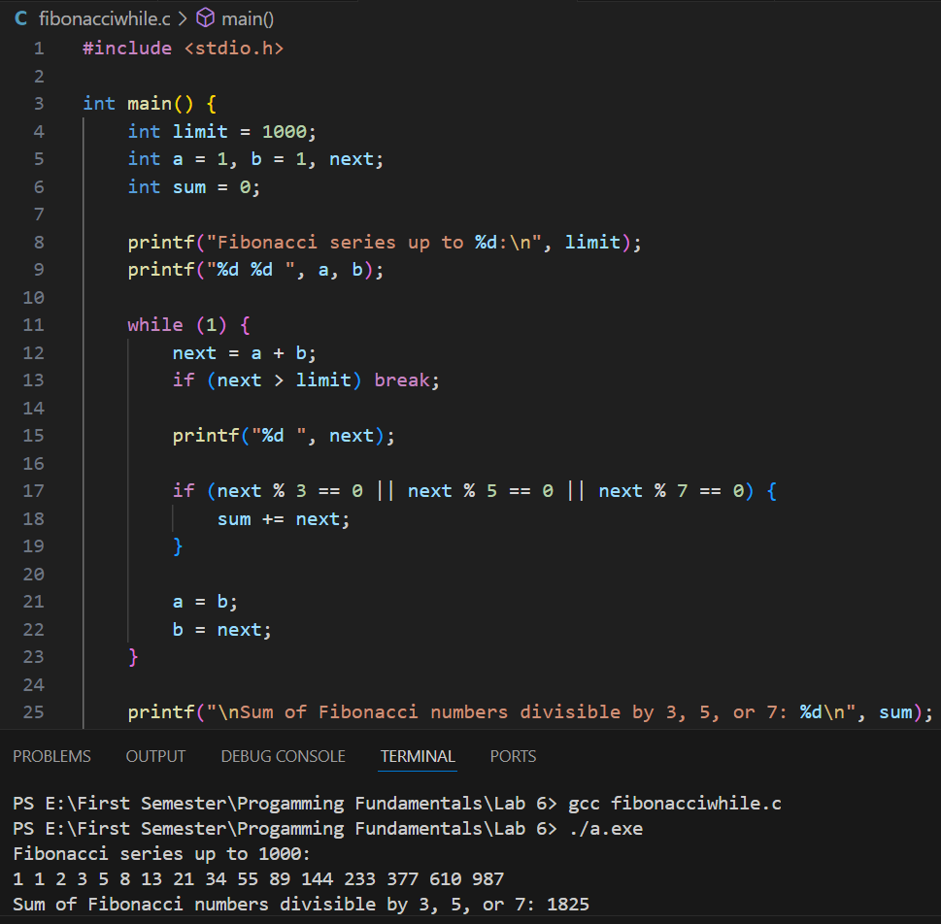

Efficiency Comparison:

* Both versions essentially do the same thing and we have the same time complexity.
* The **for loop** has a fixed range determined by the number of iterations, making it easy to read and understand.
* The **while loop** continues based on a condition, which can make it a bit more flexible for scenarios where the termination condition might not be fixed at the start.
* In this case, they are equally efficient in terms of performance.

1. Write a program which will input a 5-digit number. If the sum of digits is even, find whether the input number is a prime or not. If the sum of digits is odd find, whether the number is palindrome or not?

**Example of prime number:** A number which is only divisible by itself and 1 i.e., 7, 11, and13.

**Example of a Palindrome:** A number whose reverse order is the same as the original number i.e., 11211, 44344.

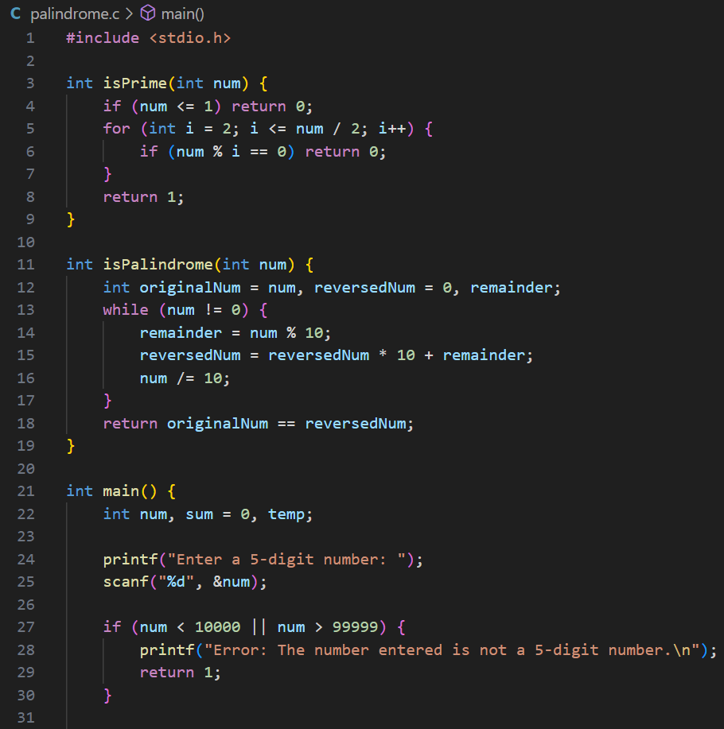

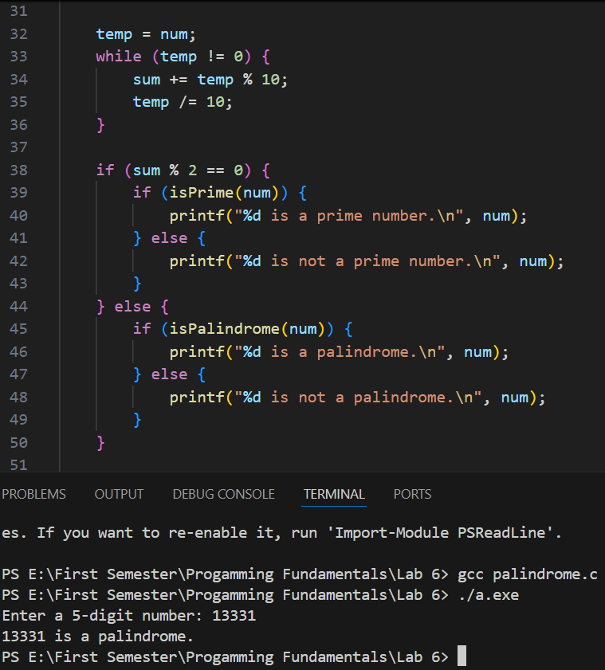

1. Develop a user-registration system have the following options.

Ask the user for a user-name (5 alphabets).

Password should be 6 characters long with at least 1 numeric, 1 capital and 1 small letter.

Display a “Account Created Successfully”.

Login the user with correct username and password.

Display “Welcome username, you are now logged in”.

**Note:** Develop your application using break and continue statement.

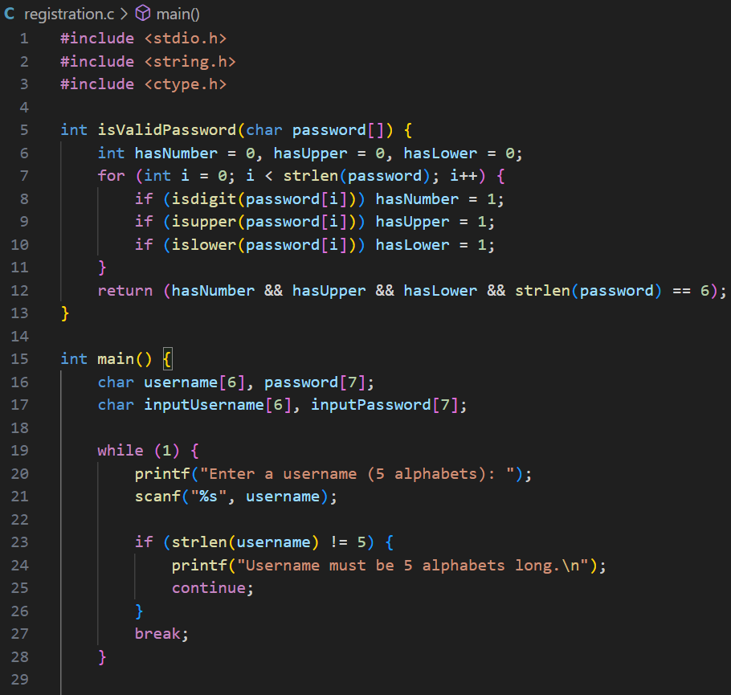

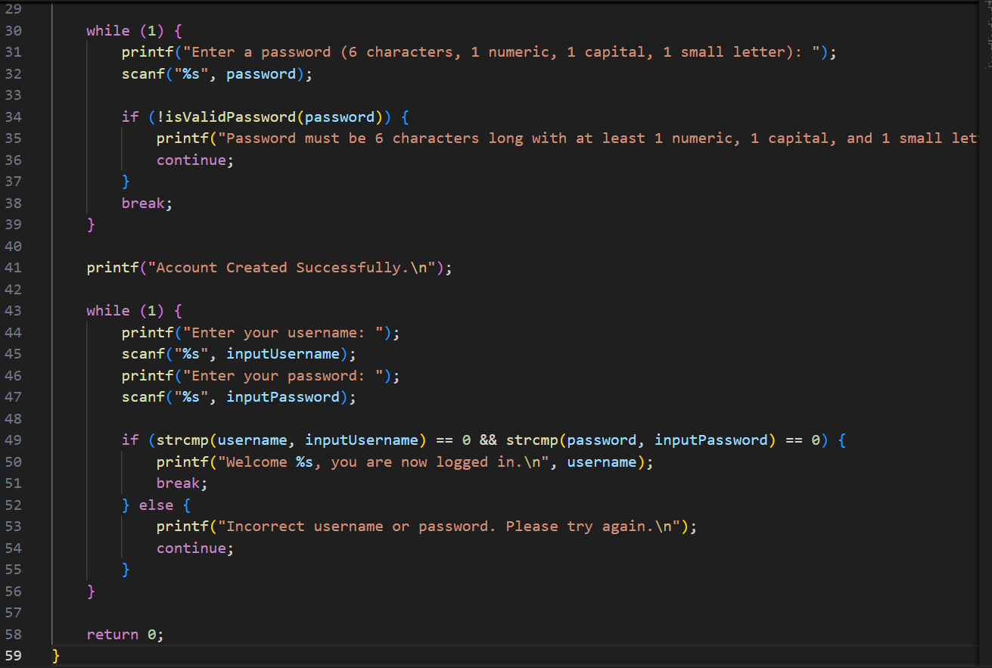

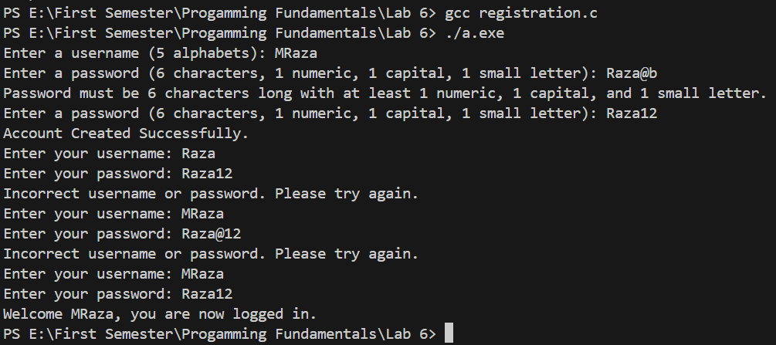

1. (Diamond-Printing Program) Write a program that prints the following diamond shape. You may use printf statements that print either a single asterisk (*) or a single blank. Maximize your use of repetition (with nested for statements) and minimize the number of printf statements.



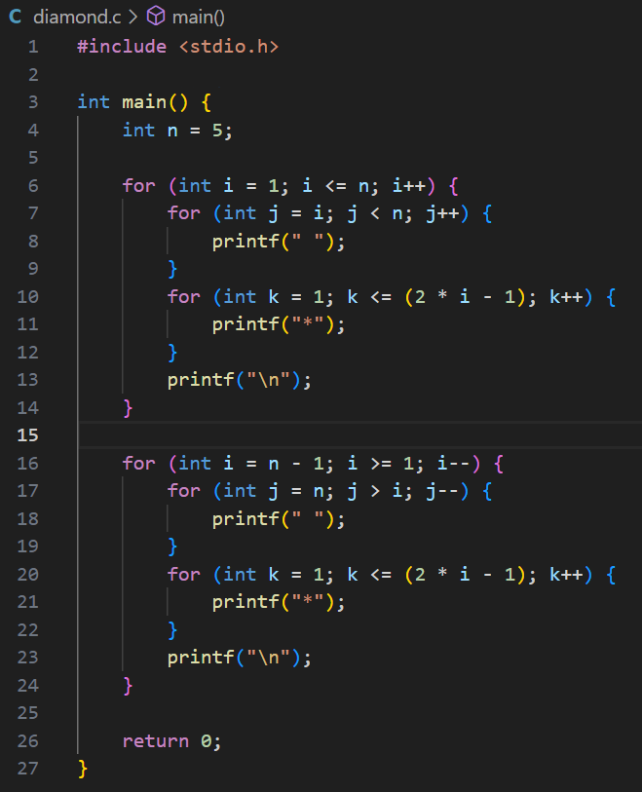

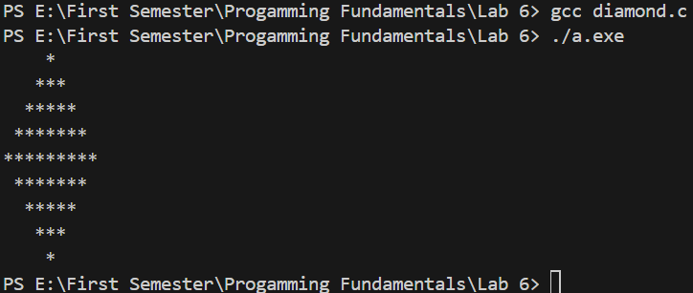

1. (Calculating the Value of π) Calculate the value of π from the infinite series. Print a table that shows the value of π approximated by one term of this series, by two terms, by three terms, and so on. How many terms of this series do you have to use before you first get 3.14? 3.141? 3.1415? 3.14159?